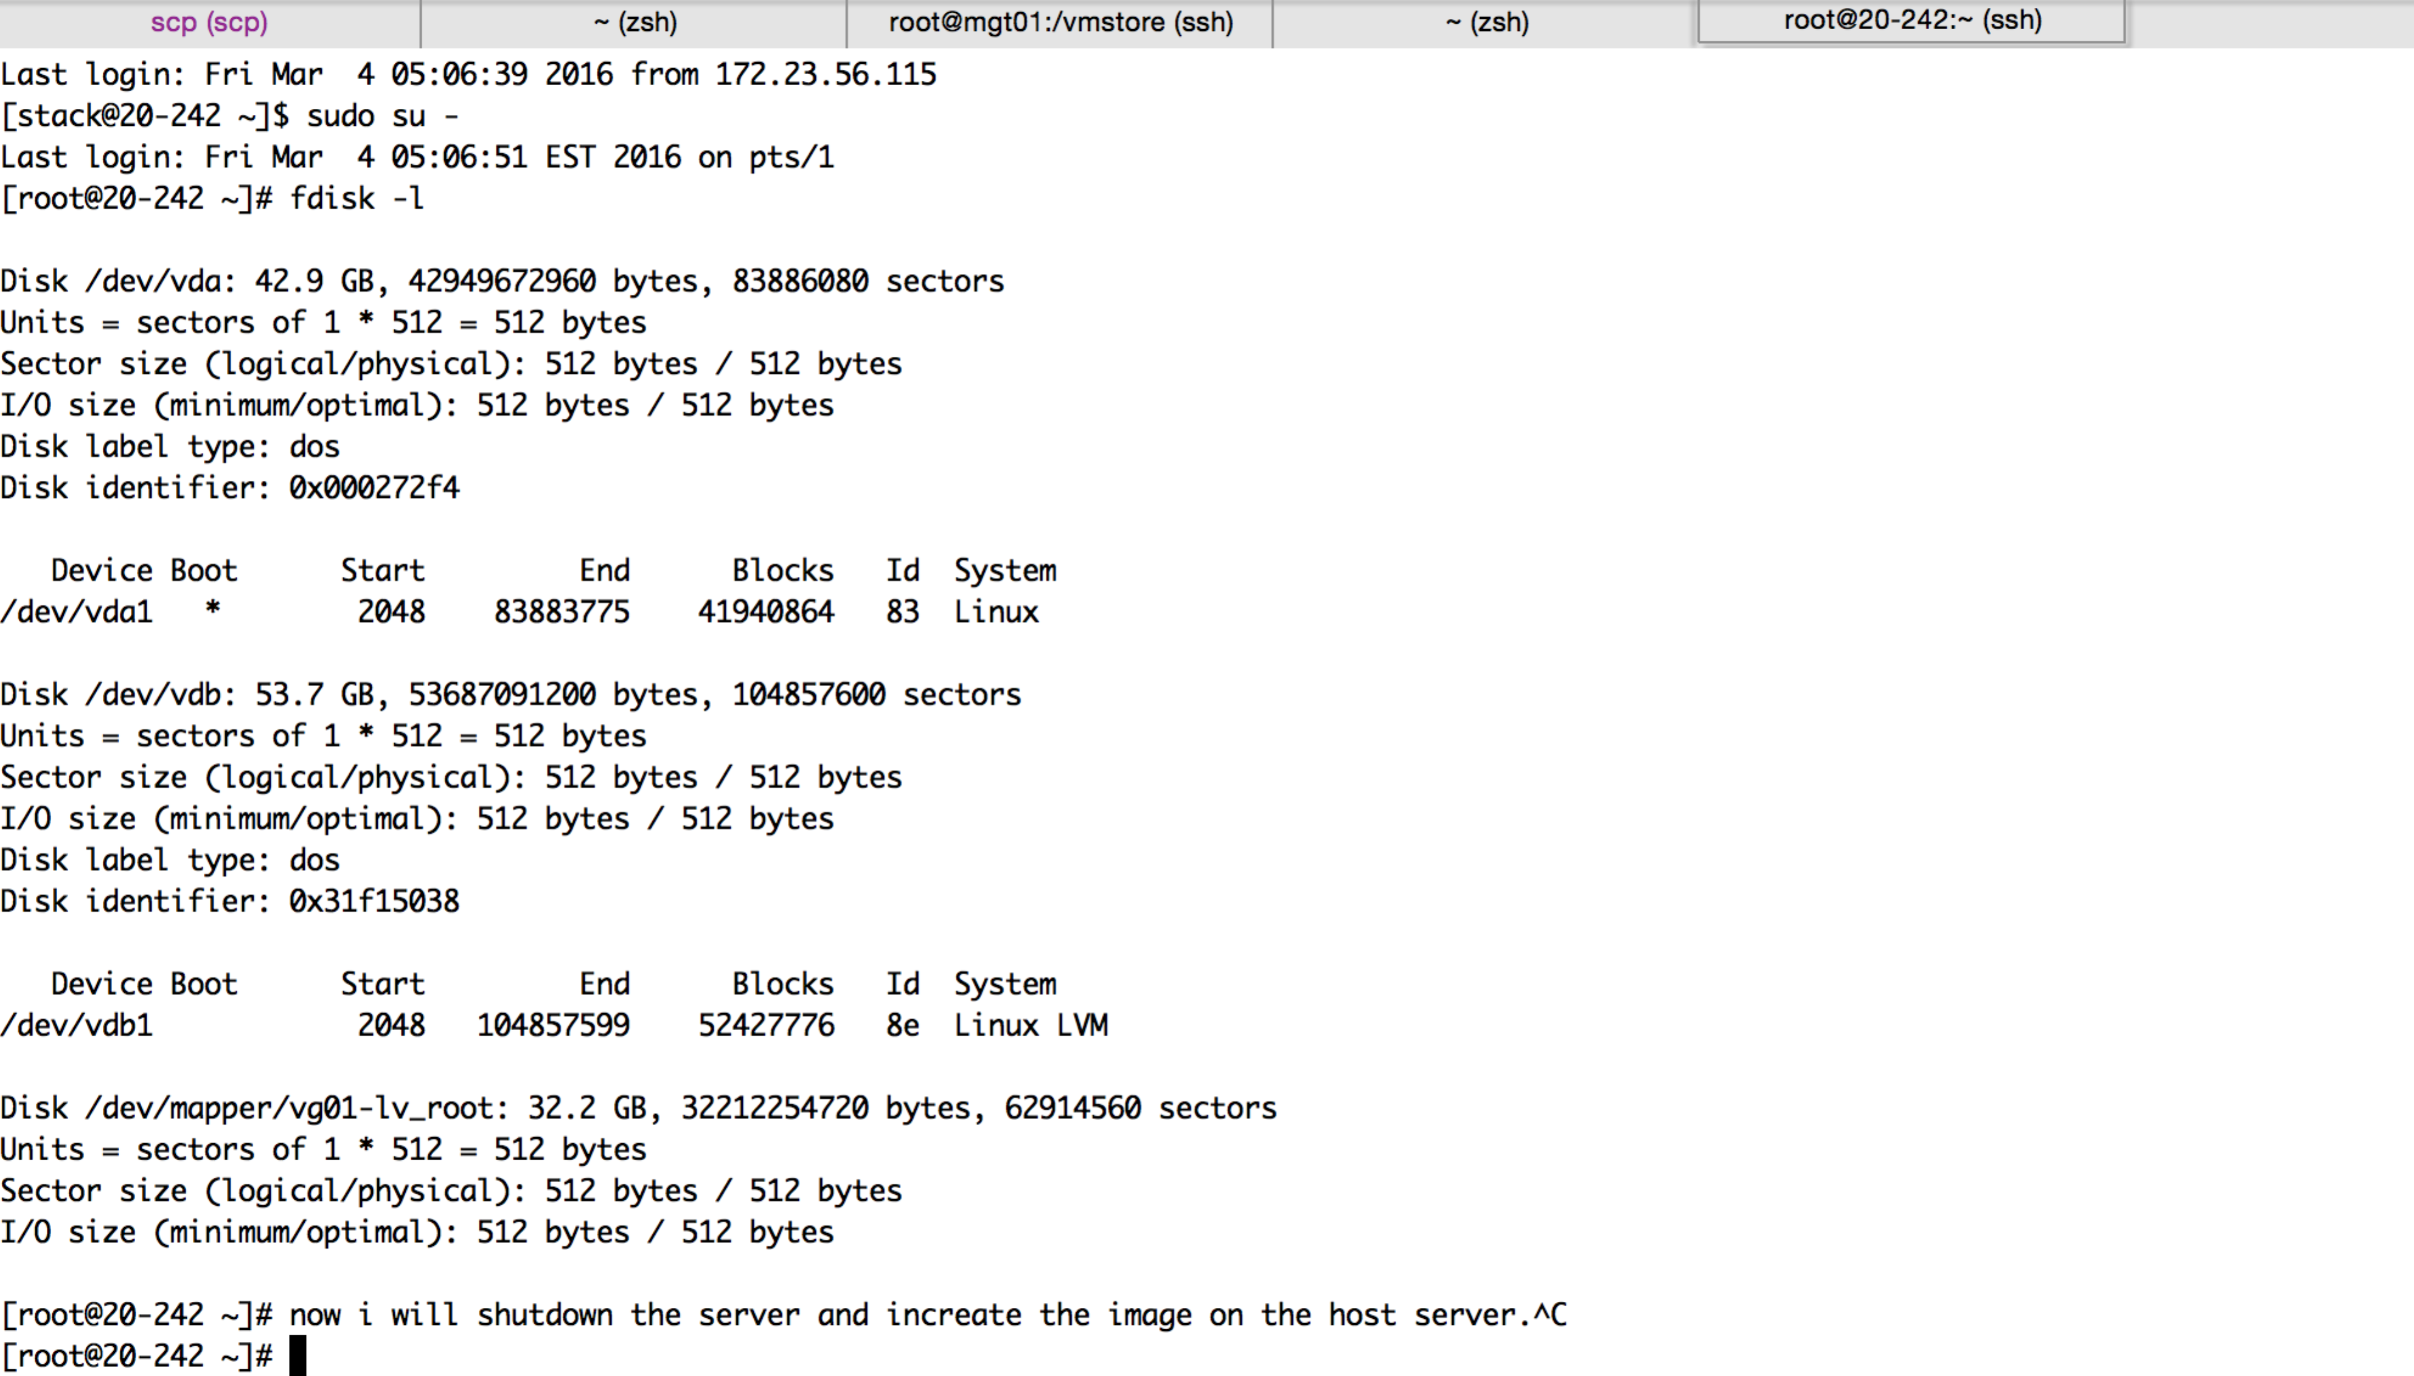

on host server

[root@mgt01 vmstore]# ls -lrth|grep undercloud-v2

-rw-r--r--. 1 qemu qemu 979M Dec 26 14:13 rhel7-undercloud-v2.qcow2

-rw-r--r--. 1 root root 321K Mar 4 18:49 undercloud-v2-disk2-clone.qcow2

-rw-r--r--. 1 root root 40G Mar 4 19:09 undercloud-v2-clone.qcow2

-rw-r--r--. 1 root root 66G Mar 4 19:11 undercloud-v2.qcow2

-rw-------. 1 root root 51G Mar 4 19:11 undercloud-v2-disk2.qcow2

[root@mgt01 vmstore]# will add 50GB disk to undercloud-v2.qcow2^C

[root@mgt01 vmstore]# qemu-img resize undercloud-v2^Ccow2 +20G

[root@mgt01 vmstore]# qemu-img info undercloud-v2.qcow2

image: undercloud-v2.qcow2

file format: qcow2

virtual size: 40G (42949672960 bytes)

disk size: 65G

cluster_size: 65536

backing file: rhel7-undercloud-v2.qcow2

Snapshot list:

ID TAG VM SIZE DATE VM CLOCK

1 undercloud-v2-virgin-snapshot 1.9G 2015-12-26 15:12:17 00:58:31.437

2 undercloud-v2-post-introspect 3.1G 2016-01-01 12:26:17 00:01:20.255

3 before reboot 2016.3.4 15G 2016-03-04 16:51:45 877:01:58.213

Format specific information:

compat: 1.1

lazy refcounts: false

[root@mgt01 vmstore]# qemu-img resize undercloud-v2.qcow2 +50G

qemu-img: Can't resize an image which has snapshots

qemu-img: This image does not support resize

[root@mgt01 vmstore]# qemu-img info undercloud-v2.qcow2

image: undercloud-v2.qcow2

file format: qcow2

virtual size: 40G (42949672960 bytes)

disk size: 55G

cluster_size: 65536

backing file: rhel7-undercloud-v2.qcow2

Format specific information:

compat: 1.1

lazy refcounts: false

--- delte all the snapshots then run again

[root@mgt01 vmstore]# qemu-img resize undercloud-v2.qcow2 +50G

Image resized.

[root@mgt01 vmstore]# qemu-img info undercloud-v2.qcow2

image: undercloud-v2.qcow2

file format: qcow2

virtual size: 90G (96636764160 bytes)

disk size: 55G

cluster_size: 65536

backing file: rhel7-undercloud-v2.qcow2

Format specific information:

compat: 1.1

lazy refcounts: false

[root@mgt01 vmstore]#

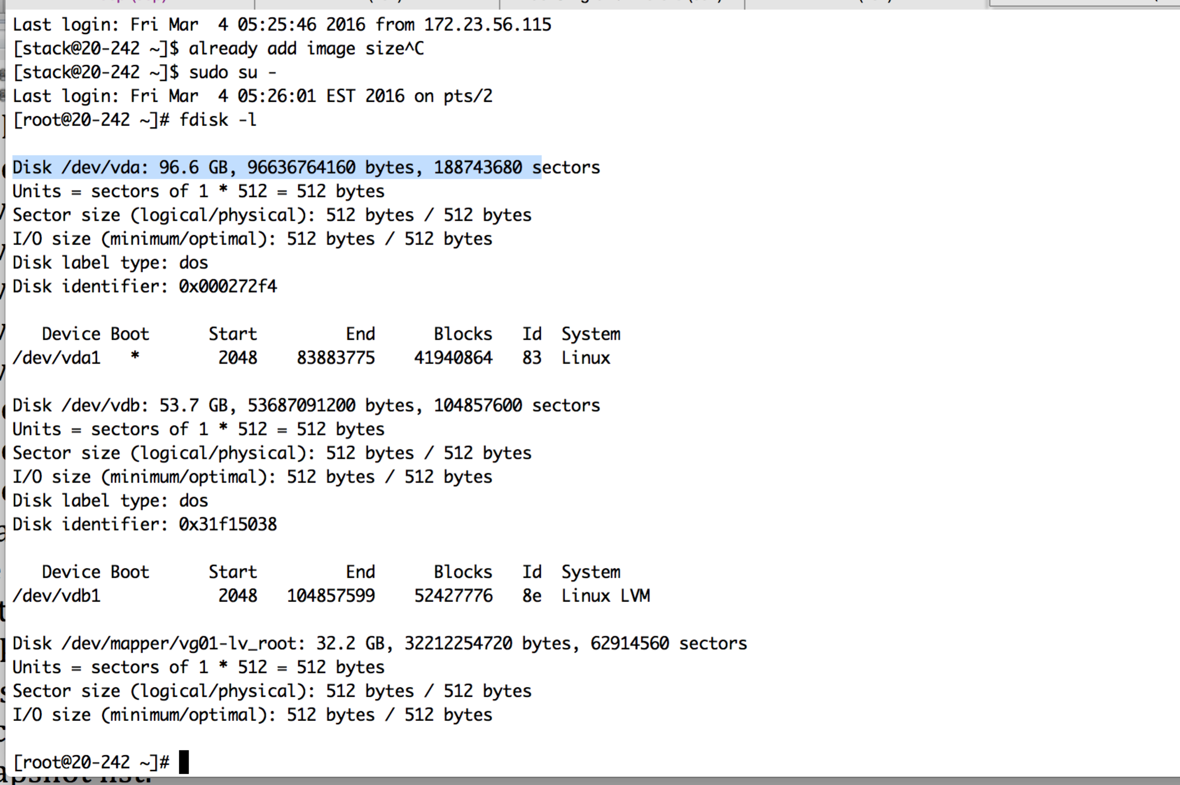

old partition

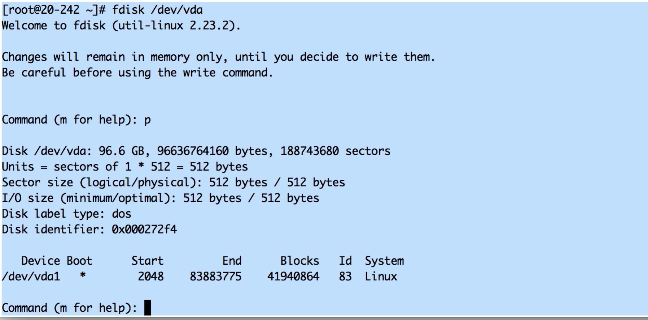

delete partion

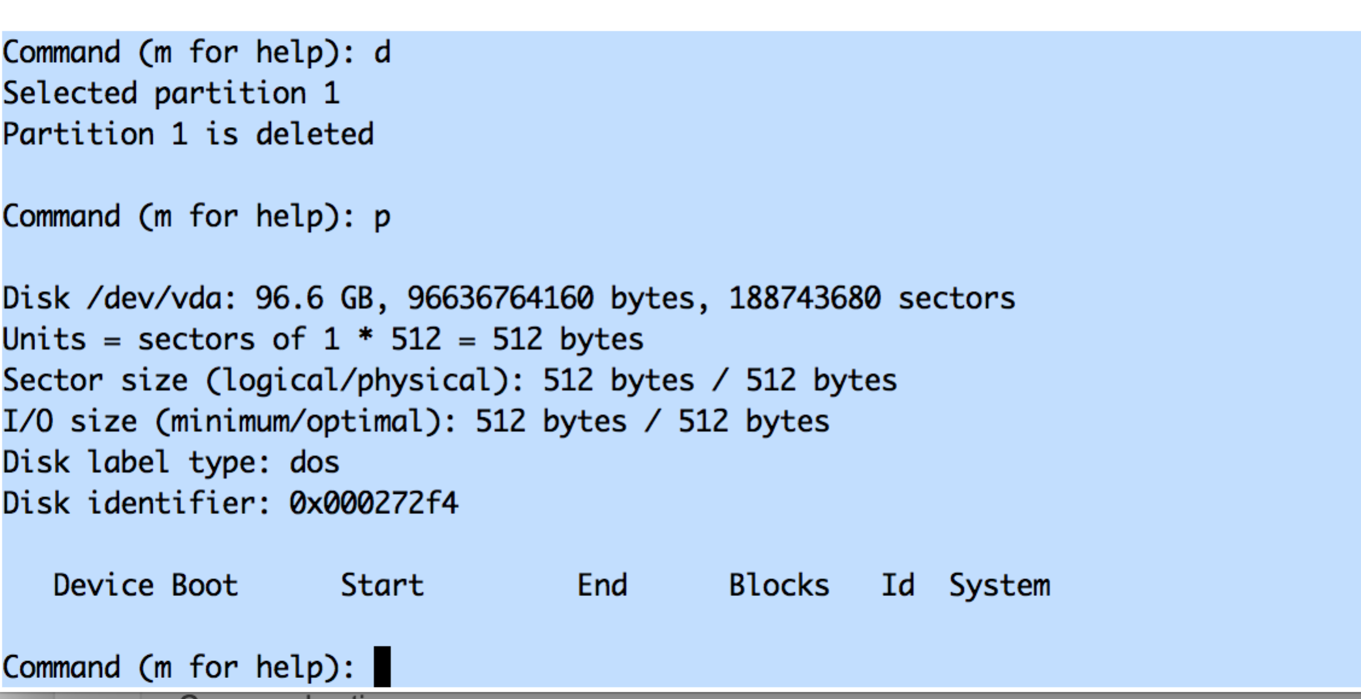

create new one

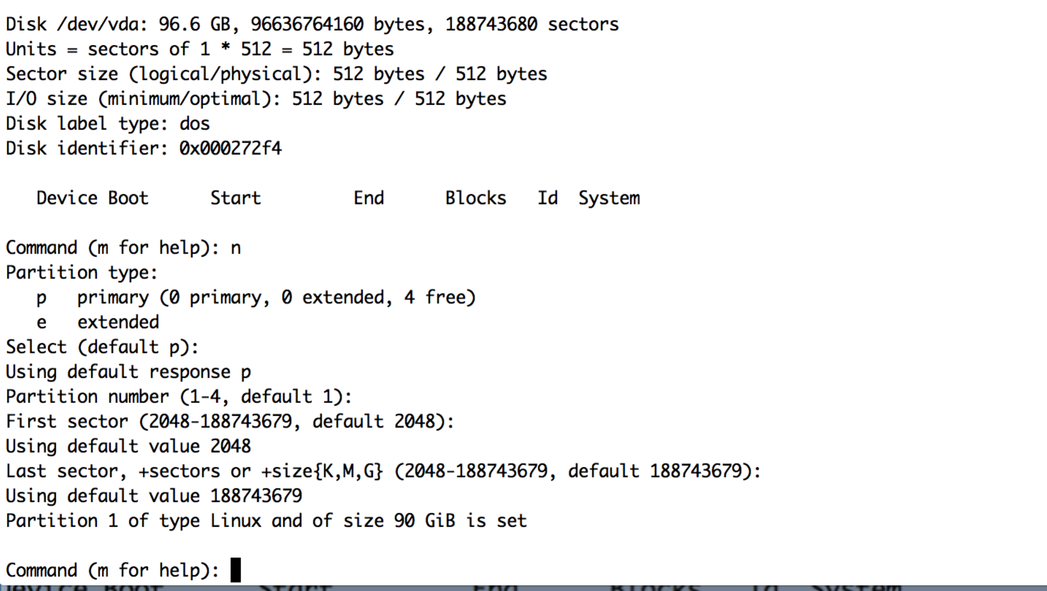

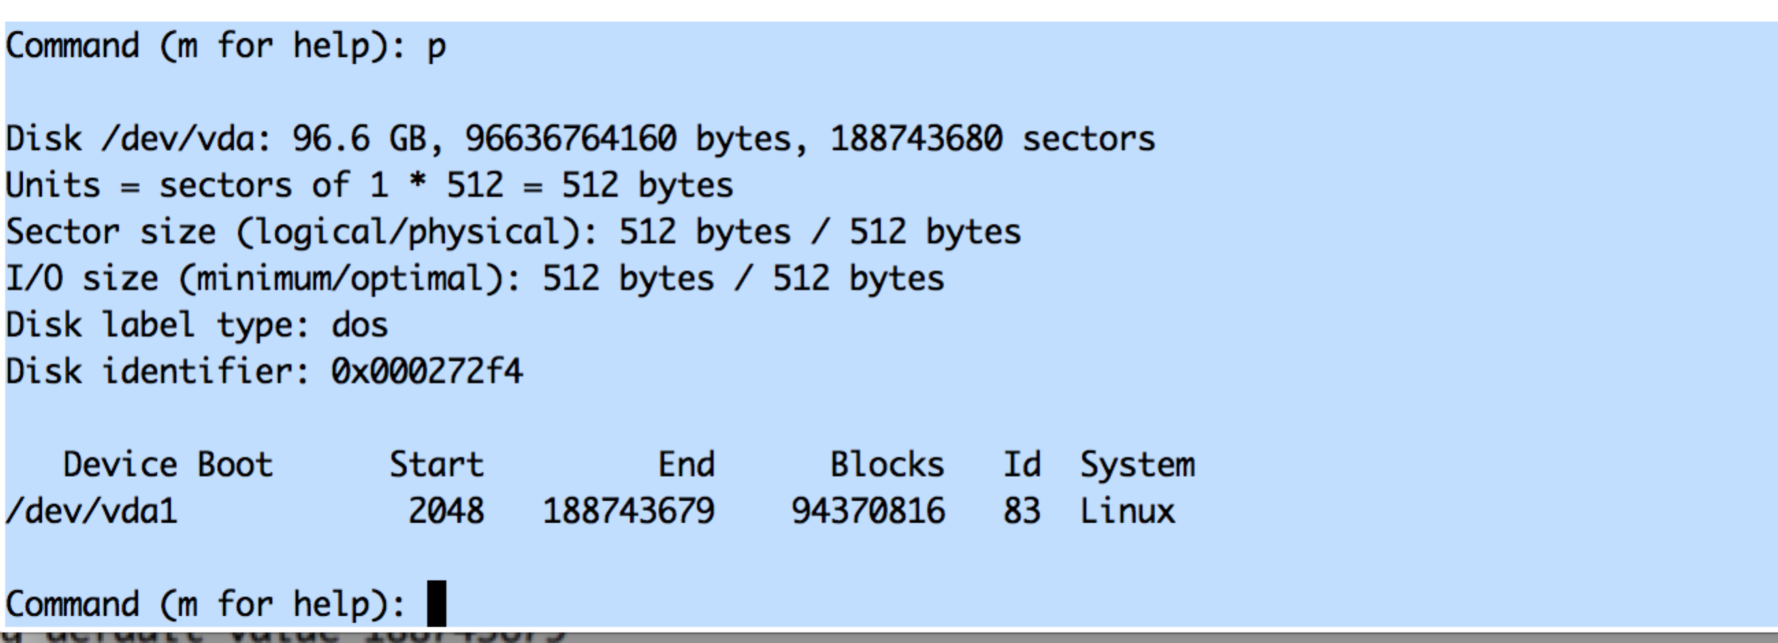

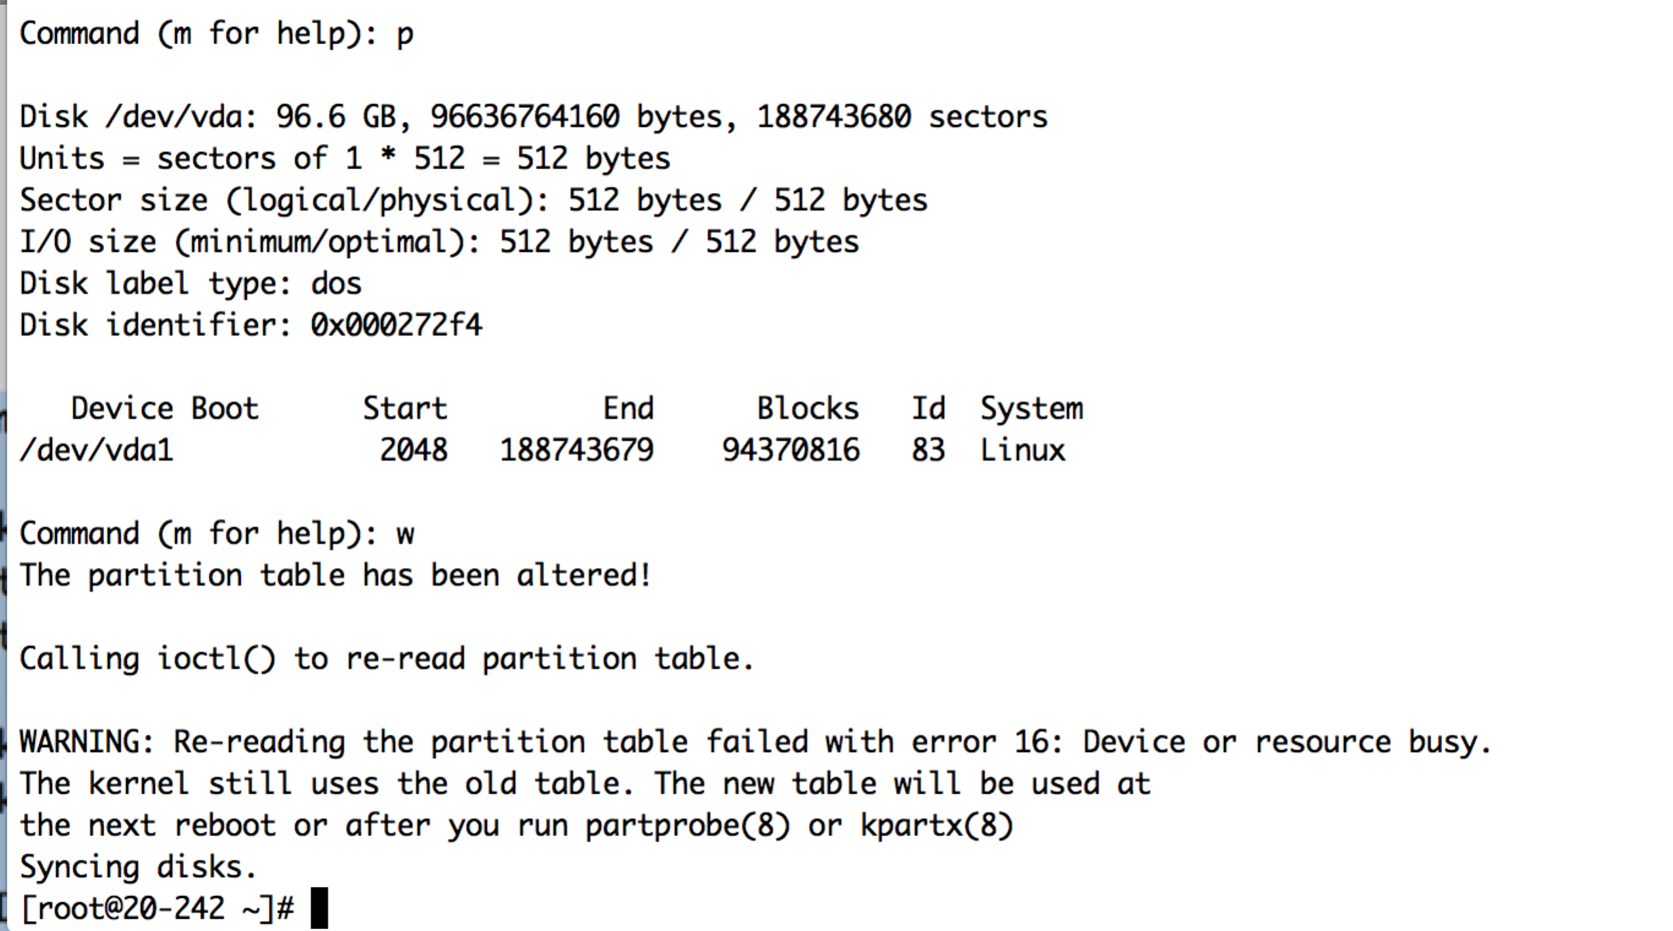

now

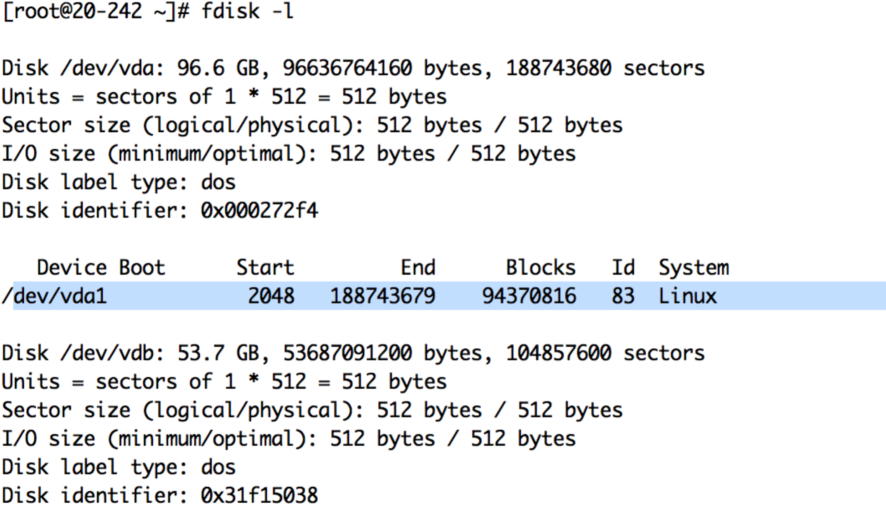

before reboot

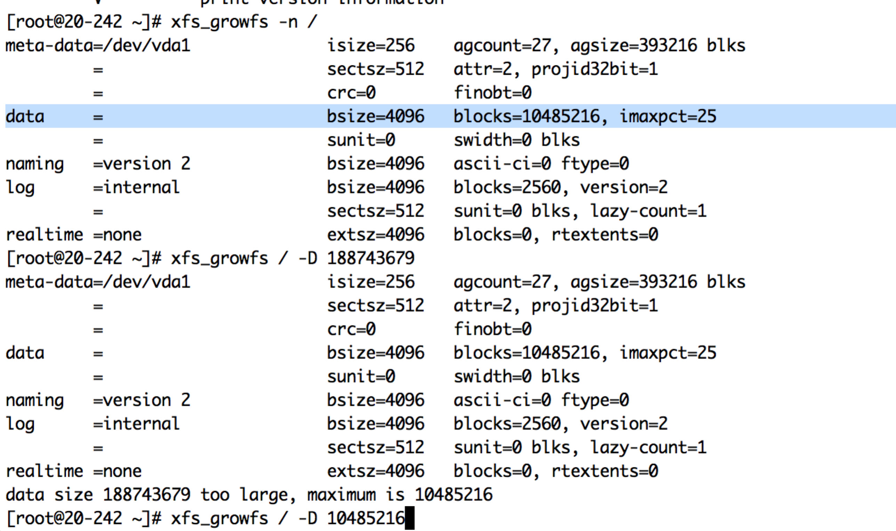

after reboot still the same

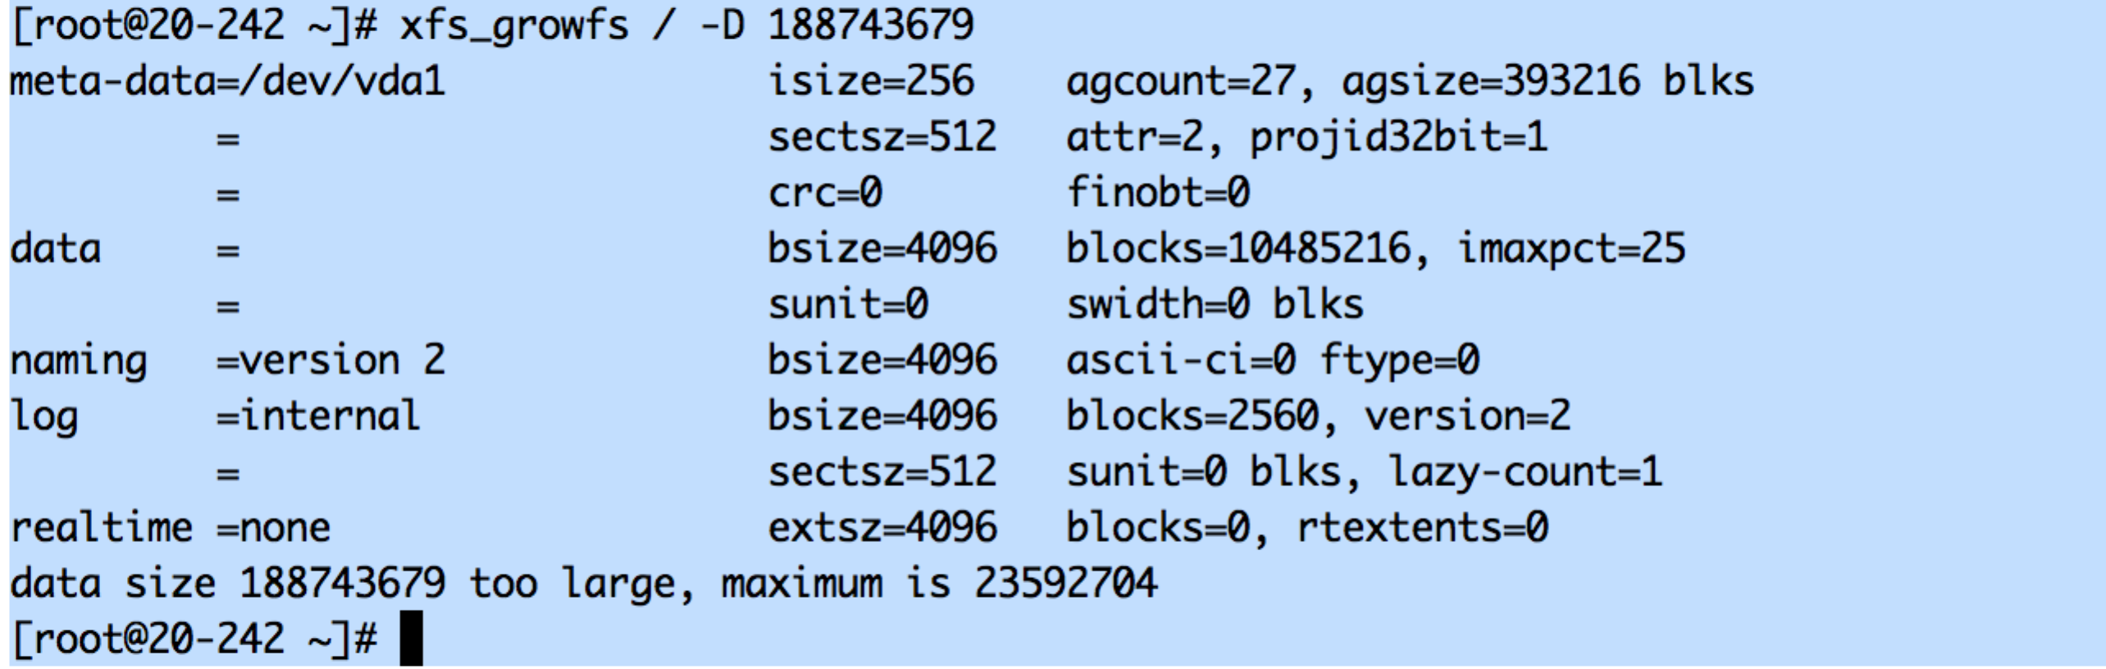

resize

